

Specification

for

Database Mirror Monitoring

Barry Searle

November 18, 2008



Proprietary and Confidential to BBS Technologies, Inc.

© 2008 BBS Technologies, Inc.; all rights reserved.

Revision history:
When? | Who? | What?
10/22/2008 | Barry | First Pass – Use cases
10/24/2008 | Barry | Rev 2 – Refined use cases using matrix
10/27/2008 | Barry | Rev 3 – Added High level use cases
10/28/2008 | Barry | Rev 4 – Incorporated suggestions from the use case review.
11/10/2008 | Barry | Rev 5
11/13/2008 | Barry | Rev 6
11/14/2008 | Barry | Rev7
11/18/2008 | Barry | Rev8

Table of Contents
1. Revision history: ii
2. Table of Contents iii
3. Requirements 1
3.1. Overview/Purpose 1
3.1.1. Related Customer Requests 1
3.2. Target Users 1
3.3. Mirroring Background Information 1
3.3.1. Operating Modes 2
3.4. Use Cases 3
3.4.1. High-Level Use cases 3
3.4.2. Low-Level Use cases 4
3.5. Feature/Function Market Requirements 6
3.5.1. Required Functions 6
3.5.2. Non-Supported Functions 6
3.6. FAQ 6
3.7. Open Issues 7
4. Functional Design 7
4.1. User Interfaces 7
4.1.1. The Real-time Mirror Monitoring Detail View 7
4.1.2. The Historical Mirror Monitoring View (reports) 10
4.1.3. Alerts – apply only to mirrored databases 12
4.1.4. Grooming 13
4.1.5. SQLdm Databases view 13
4.1.6. Issues that need to be discussed 13
4.2. Installation and Upgrade 14
4.3. Permissions and other Required Configuration 14
4.4. Licensing Issues 14
4.5. Dependencies 15
4.5.1. Dependencies on Idera Software 15
4.5.2. Third-Party Software Required on the Customer Machine 15
4.5.3. Third-Party Software Required Internally 15
5. Internal Design 15
5.1. Architecture 15
5.1.1. Front-end (non-repository) 15
5.1.2. New tables in the repository 16
5.2. Installation Issues 17
5.3. Schedule 17
5.3.1. Work Breakdown and Sizings 17
5.3.2. Areas of Risk 18
6. Quality Assurance Considerations 18
6.1.1. Overview 18
6.1.2. Developer-Created Unit Tests 18
7. Debated, but not in the release… 19
7.1.1. The Real-time Mirror Monitoring Overview 19
8. Documentation Considerations 19
9. Bibliography 20

Requirements

Overview/Purpose
This feature is designed to provide an overview of mirroring relationships that have been set up on monitored servers. The mirror monitoring screen will show at a glance all mirrored databases on a server by clicking on a “mirror monitoring” button on the databases tab of the ribbon.
There will also be an alerting component. Users may have mirroring setup to automatically fail over. In this case they need to be alerted to the fact that a failover has occurred. They will be alerted to any role changes and communication interruptions between members of mirroring relationships.
We allow the user to perform a number of mirroring control actions on the server.
It is important to note that once a server goes down, we do not have access to any information on that server. If the partner is being monitored we will alert the user to the fact that a partner is no longer contactable.

Related Customer Requests
PR 12153 – Albert Lavie from New York and company would like to be informed if there is a communication exception between the principal and the mirror.

PR2011902 – Michael Shannon with Cybertrader would like to be able to monitor the status of a mirroring relationship and also be able to failover from SQLdm when patches need to be installed on the host servers.

PR2011331 – Jim Helm at Graham-field would like to be alerted to issues related to mirroring between his servers\databases.

Target Users
This feature targets larger customers who have a need for full redundancy and very fast failover. Mirroring does require three servers so it does have significant overhead. The user of this feature will be the database administrator of a heavily SQL Server dependant organization.

Mirroring Background Information
Database Mirroring has been supported since SQL 2005 SP1.

Partner databases keep mirroring information that allows us to monitor the availability and efficiency of the witness (if applicable) and the other partner. The user does not need to specifically connect to the mirror to find out the current restore rate or if the mirror is inaccessible.

The witness does not maintain mirroring metrics other than a connection state to each partner. This connection state is available from the partners and so the witness does not need to be monitored at all in order to report on its availability.

A few database mirroring features require SQL Server 2005 Enterprise or Developer Editions:
• | High Performance mode with safety OFF (asynchronous data transfer);
• | database snapshots
• | Use of multiple threads for replaying the transaction log on the mirror database (parallel REDO).
SQL Express and the Workgroup Edition can be used as a witness server, but they cannot be used as a partner server in database mirroring.

Database mirroring is a primarily software solution for increasing database availability. Mirroring is implemented on a per-database basis and works only with databases that use the full recovery model. The simple and bulk-logged recovery models do not support database mirroring. Database mirroring is supported in SQL Server Standard Edition and Enterprise Edition.

Database mirroring offers a substantial improvement in availability over the level previously possible using Microsoft SQL Server and provides an easy-to-manage alternative or supplement to failover clustering or log shipping. When a database mirroring session is synchronized, database mirroring provides a hot standby server that supports rapid failover with no loss of data from committed transactions. During a typical mirroring session, after a production server fails, client applications can recover quickly by reconnecting to the standby server.

In SQL Server mirroring there are up to 3 participants:
- The Principal – The currently active database.
- The Mirror – The standby database.
- The Witness – Serves only to form a quorum with the available server to determine without human intervention that a server is no longer available.

Operating Modes
There are three possible operating modes for a database mirroring session. The exact mode is based on the setting of transaction safety and whether a witness server is part of the mirroring session.
Table 1: Database Mirroring Operating Modes
Operating Mode | Transaction safety | Transfer mechanism | Quorum required | Witness server | Failover Type
High Availability | FULL | Synchronous | Y | Y | Automatic or Manual
High Protection | FULL | Synchronous | Y | N | Manual only
High Performance | OFF | Asynchronous | N | N/A | Forced only

High Availability
This mode supports automatic failover when the Principal goes down. It requires a witness server to form a quorum with the server that is still available. Once an automatic failover has occurred it requires a manual failover to restore the roles to their pre-failover state.
Transfer is synchronous and a transaction is only committed once the mirror has logged the transaction. There is a negative performance impact for this level of transactional safety.

High Protection
High Protection mode offers the maximum transactional safety, but requires the administrator to manually failover to the mirror node. It has the advantage of not requiring a witness but could result in significant downtime.

High Performance
This mode can be equated with asynchronous log shipping. The transactions are asynchronously sent to the mirror without any handshaking to ensure that the transactions were committed. If the principal gets ahead of the mirror and a failure occurs some transactions will be lost. The advantage is that there is no performance overhead incurred on the Principal. There is also no witness because automatic failover is not offered.

Use Cases

High-Level Use cases
- DBA would like to see what mirrored databases (Partners) are being monitored across all of his monitored servers and what mirrors (if any) they are using.
- DBA would like to see what mirrored databases (regardless of role) are available on a monitored instance and what mirrors they are using.
- DBA would like to see the current status of a mirrored environment.
- DBA would like to see the status of the mirrored environment as of yesterday at 1pm (for forensic analysis).
- DBA would like to be notified if any part of their mirrored environment is down/lost or not functioning.
- DBA would like to see when the performance of the primary machine is being impacted due to mirroring.
- DBA would like to be able to see a real-time view of mirroring metrics, allowing him to make a decision as to the optimal time to perform a manual failover.
- DBA would like to be alerted when certain mirroring related performance thresholds are exceeded on one of the Partners.
- DBA would like to change, perform maintenance or upgrade the primary machine and so would like to manually fail-over to the secondary machine temporarily (partner might not be a server we are monitoring).
- DBA would like to fail-back to the primary machine (after maintenance is complete)
- DBA would like to configure or setup mirroring (deferred)
- DBA would like to be presented with an overview of the historic availability, and alerts from the entire mirrored environment (or one specific mirrored environment). This takes the form of an emailed or previewed report.
- DBA would like to define an accepted “normal” mirroring relationship.
- DBA would like to be alerted when a “normal” mirroring member is removed.

Low-Level Use cases
Alerts
- SQLdm alert is raised from a Partner when the connection to another partner has been lost.
- SQLdm alerts the user to the loss of a witness.
- SQLdm alert is raised warning a monitored partner’s role has changed due to the unexpected loss of a server.
- An alert should be raised from both Partners warning than the status of the connection to the witness has changed.
- SQLdm Alerts the user to the fact that the connection to a partner has been restored.
- SQLdm alerts the user to a controlled change in role between partners.
- SQLdm alerts the DBA when mirroring is suspended.
- SQLdm may be configured to alert if unsent log exceeds threshold (deferred – this can be done from SSMS).
- SQLdm may be configured to alert if un-restored log exceeds threshold (deferred – this can be done from SSMS).
- SQLdm may be configured to alert if age of oldest unsent transaction exceeds threshold (deferred – this can be done from SSMS).
- SQLdm may be configured to alert if age of oldest unsent transaction exceeds threshold (deferred – this can be done from SSMS).

Real-time view
- SQLdm displays in a real-time view, the mirroring connection status to a partner.
- SQLdm displays in a real-time view, the mirroring status of the connection to a witness.
- A Partner databases real-time view should display Transaction safety.
- SQLdm displays in a real-time view, the current role of a partner.
- SQLdm displays real-time metrics available for a participants in mirroring including send rate, restore rate, witness address and operating mode.
Actions
- SQLdm allows the user to manually failover the principal role between partners, only if failing back will be possible.
- SQLdm allows the user to pause mirroring. The DBA can simply resume mirroring when she is ready.
- SQLdm allows the user to stop mirroring – This cannot be reversed so we will not allow this.
Reports
- The DBA can view a report that displays the mirroring history for a selected database. This includes rates of communication, data transfer rates and role.
- The DBA can view a report that displays the current mirroring status, current roles and failover conditions of all monitored servers. This will be useful for scheduled emails.

Use Case | High Availability (inc High Protection) | High Protection | High Performance
1 | Y | Y | Y
2 | Y | N | N
3 | Y | Y | Y
4 | Y | N | Y
5 | Y | Y | Y
6 | Y | Y | Y
7 | Y | Y | Y
8 | Y | Y | Y
9 | Y | Y | Y
10 | Y | Y | Y
11 | Y | Y | Y
12 | Y | Y | Y
13 | Y | N | N
14 | Y | Y | Y
15 | Y | Y | Y
16 | Y | Y | Y
17 | Y | Y | N
18 | Y | Y | Y
19 | Y | Y | Y
20 | Y | Y | Y
21 | Y | Y | Y

Feature/Function Market Requirements
Mirroring is a hot new technology that allows a DBA to configure a duplicate of their important databases for performance, availability and redundancy. There is no way a user can get an overview of the status of mirroring that has been implemented across servers. Our aim is to provide them this overview as well as a control panel allowing them to keep in touch with statuses, be alerted to issues and be able to take actions all in one convenient view.

Required Functions
- Users will be able to navigate to the database tab of the ribbon and click on a “Mirror Monitoring” button to get to the new “Database Mirror Monitoring View”
- User will be able to view mirrored databases on all of his monitored servers.
- User will be able to see current mirroring status of the mirrored databases.
- User will be alerted to mirroring role changes that occur within databases on monitored servers.
- User is able to manually failover to mirror servers using FULL transaction safety.
- User is able to pause mirroring.
- User is able to resume mirroring.
- User is able to remove mirroring for a database.
- User can view the mirroring history for a selected database.
- User can view a report showing the mirroring status and failover conditions of all mirroring partner databases on all monitored servers. This will be useful for scheduled emails.

Non-Supported Functions
- We are not creating a mirroring wizard that allows the user to easily set up mirroring. Setting up mirroring is a very involved process that is impacted by networking and security configuration that are outside the scope of this specification at this point. It is certainly an area offers great opportunity for this product or other products in the company. A wizard that takes the user step by step through the process of setting up the mirroring process would add a lot of value.
- We do not allow the user to take snapshots of databases. This is the only way for a user to access the content of a mirror and so I believe that it would add significant value, but it is outside the bounds of this specification.

FAQ
- “Is mirroring an instance or a database level feature?” – Mirroring is a database level feature. Databases on a single server might be mirrored to databases on the same number of distinct instances.
- “How much mirroring data relating to a partner is available, if the partner instance goes down?” – We still have access to the sys.database_mirroring table on the active partner. This tells us the configuration and also tells us that a partner is disconnected. If however, the DBA does not know the name of the active partner, he will not be unable to gather any information at all. He will be unable to drill into the active partner because we do not allow navigation into servers that are unavailable. It might be better to have a high level Mirror monitoring definition wizard screen where we allow the user to define the partners, the witness and the mirroring mode.

Open Issues
- On the SQLdm databases view, we currently show the Principal server in a mirroring relationship as “shutdown cleanly”.
- On the SQLdm databases view we currently show the recovery model of a mirror in a mirroring relationship as “SIMPLE”.
- Schwab requests that we support a mirrored repository. This should be as easy as adding in a “failover_partner” parameter to the connection string.

Functional Design

User Interfaces

The Real-time Mirror Monitoring Detail View
There is no “All Servers” mode for real-time viewing of mirroring.
The real-time view is very similar to the existing database view. It allows the DBA to view all mirrored databases on a server or to select a particular database on the current server. Regardless of whether you are viewing all databases or a single database, clicking on a row in the table fetches current values for various real-time metrics and displays them in the lower portion of the screen.
The relationships are derived from data returned from mirroring related views that are queried at every scheduled refresh. These relationships provide the information that is required to set the “normal” or “failed-over” state. This normal state is stored in an additional relationships table.
When DM is not monitoring any of the members of the mirroring relationship we get as much information as possible from the monitored members.
The relationship information that we can get from 1 partner is:
- Partner name
- Partner instance
- Witness name
- Current Role
- Mirroring State
- Witness connection state
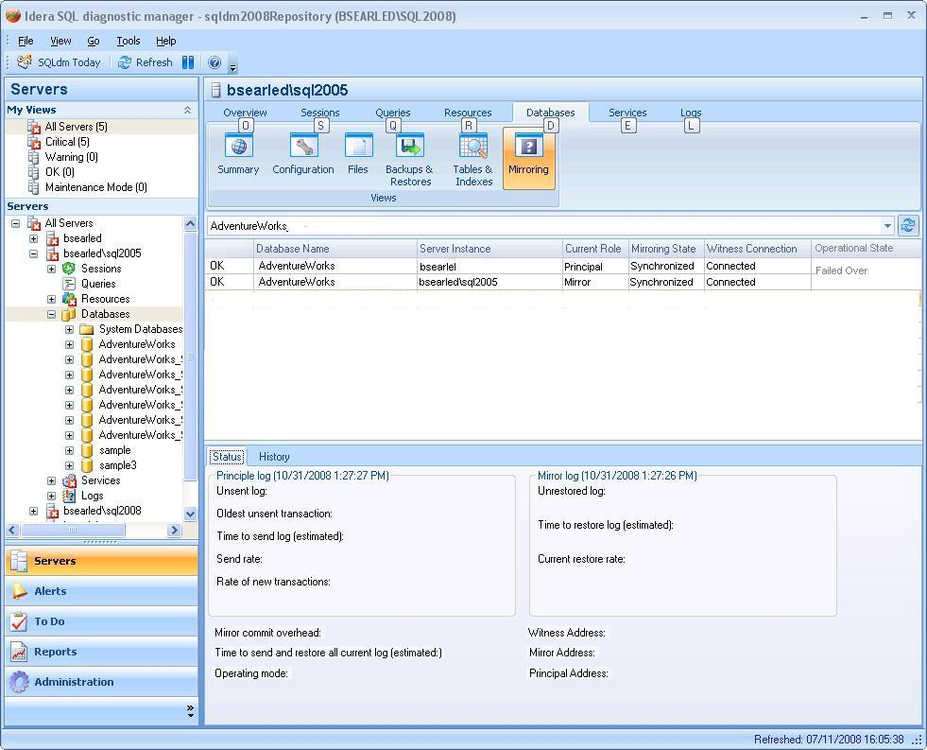
There will also be a “show group by box” checkbox in the ribbon. This will allow the user to drag a column by which he will group the contents of the table. The current role, mirroring state and operational status columns will be colored depending on the existence of an error condition.
Columns in the Mirrored Databases table:
- Database name
- Server Instance
- Current role – Red if there is a deviation from specified “normal”.
- Mirroring state – Red if not synchronized.
- Witness Connection - Red if not connected.
- Operational Status – Derived from deviation from specified “normal”. Red if not normal.

Actions that can be performed from the Mirrored Databases table:
Each row of the table will have a context menu that will allow you, depending on the operating mode to
- fail over
- Suspend/resume mirroring.
- Set this mirror relationship as “normal”
- Set this mirror relationship as “Failed over”
- Set this mirror relationship to “role agnostic”.
We only allow actions to be performed if they can be reverted from within our system. The user must be monitoring the partner and failing over must not result in data loss. Also, the user must have rights on the secondary server to fail back before we should allow the user to fail over.

Note: We have not reached agreement on this issue. There is a strong argument in favour of allowing the user to fail over, regardless of the ability to fail back. It is not really our place to enforce these policies. We should assume that the users are capable of configuring their own system according to their requirements. Users might not want to waste a SQLdm license on monitoring a mirror server, especially in an environment where they have specified a preferred mirror.

When the user is on the real-time mirror monitoring view and they perform an action, the application must verify that the data represented in the grid is still representative of the mirroring relationship. It could have been changed manually via enterprise manager or another SQLdm console since the screen was populated and it should validate its data before applying any actions. If this validation fails, the user must be notified that the data has expired and a refresh will automatically be performed, ensuring that the user now has the most current data at his disposal.

While actions are being performed, we will feed back as much status information as possible. Actions such as a fail over could take a long time and the user needs whatever information we can provide. Actions will be performed asynchronously to elimate blocking should the action take a long time.

In “All Databases” mode (before selecting a database) the bottom panel will be hidden. Clicking on a row will populate the bottom panel with the following real-time metrics:
Status Tab
- Principal log last updated time
- Unsent log (KB)
- Oldest unsent transaction
- Time to send log(estimated)
- Current send rate (KB/sec)
- Current rate of new transactions (KB/sec)
- Mirror log last updated time
- Un-restored log (KB)
- Time to restore log
- Current restore rate (KB/sec)
- Mirror commit overhead (ms)
- Time to send and restore all current log (estimated)
- Principal Address
- Mirror Address
- Witness address
- Operating mode

History Tab
- The history tab has a combo box that allows the user to select the following options:
  - Last 2 hours
  - Last 4 hours
  - Last 8 hours
  - Last day
  - Last 2 days
  - Last 100 records
  - Last 500 records
  - Last 1000 records
  - All records
- The History tab shows all of the above metrics as well as a time stamp indicating the sample time during the selected period.
- The time selections are dictated by the system stored procedure that is provided to return the mirroring metrics.
- Accessing this view
  - This view can be accessed from the server view ribbon control.
  - This view can be accessed directly from the tree.

The Historical Mirror Monitoring View (reports)

Current status across one\all servers
- Populated from the mirroring participants table.
- Has an option to show only mirrors with problems (mirrors that have a disconnected witness or a status other than synchronized).
- Role field is colored according to the deviation from the specified “normal” role for this instance if one has been specified.
- Fields
  - Server
  - Database
  - State
  - Role
  - Witness
  - Witness State
  - Operational status – This field will be derived from the deviation in role from the designated “normal”.

Mirroring history across one\all servers
- Shows the same data as can be seen on the history tab of the real-time view, captured with each scheduled refresh of the collection service.
- Data is gather from the mirror monitoring history table in our repository.
- Mirror monitoring history table is populated from the scheduled refresh.
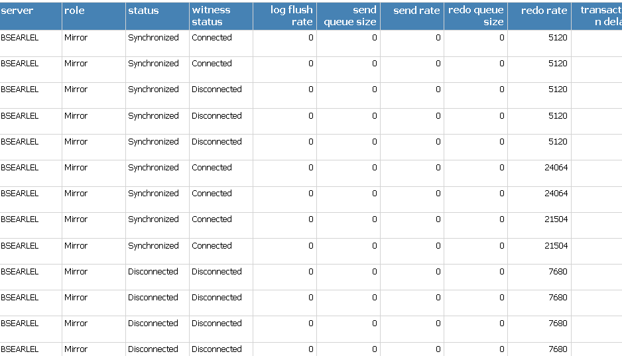

Monitored Server Configuration
- Database
- Principle
- Mirror
- Witness
- State

Alerts – apply only to mirrored databases
This feature will alert users to changes in the state of mirror monitoring on monitored servers as well as changes in role of mirrored databases.
- Performance
  - Unsent log threshold (KB)
  - Unrestored log (KB)
  - Oldest unsent transaction (minutes)
  - Mirror commit overhead (ms)
- Database mirroring status - We will allow the user to select critical and warning statuses from the available statuses of mirrored databases. If a scheduled refresh returns a mirroring status that exists in the list of critical statuses for an enabled mirroring alert, an appropriate notification will be sent.
- Database mirroring role – The role for a Principal might not be good for a mirror so we must differentiate between the 2 partners.
  - Database mirror partner has taken on a non-preferred role. This alert does not reset over time. It tells the user that the roles in the mirroring relationship do not conform to the specified “normal”. This alert remains until the roles are restored or the DBA changes the “normal” state.
  - Database mirroring role change – This is simply an alert that is generated when the role changes. The user would be alerted to the role change and under advanced setting they can set a period of time whereafter the alert must reset. This is for users who have no preference over which partner takes which role.
The 2 database mirroring roles are different. The one alert tells the user that a failover has occurred and the other alert tells the user than the failover has resulted in the mirroring roles being assumed by a non-preferred role configuration. If both of these alerts were enabled on a server and a failover occurred from primary to secondary there would be 2 alerts logged. When failing back there would only be a single role change alert.
Note: There has been much discussion about whether these 2 alerts are necessary because they appear to be very similar. While this is true, there are a number of reasons why users would always prefer a specific server to be the principal.
Applications targeting a mirrored database must have a primary and secondary in the connection string. They connect first to the primary. If the secondary is the principle there will be a timout in the initial connection.
Jobs are not mirrored. There is a lot of infrastructure that needs to be duplicated between servers that host mirroring. If the primary purpose of mirroring is to maximize availability during brief outages for application of service packs, then the DBA might choose not to duplicate all of the agent infrastructure on the secondary. In this case the mirroring relationship assuming a non-preferred role is a very critical alert.
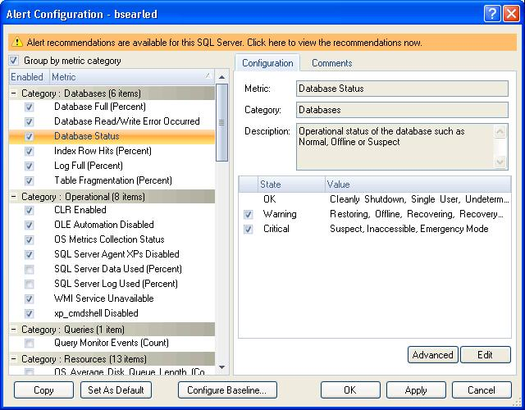

Grooming
The mirror monitoring tables need to be groomed as part of the schedule grooming operation.

SQLdm Databases view
In the database summary screen the databases need to include the mirroring status in the displayed status field if the database is mirrored.

Issues that need to be discussed

Does the Mirror Monitoring feature lend itself to being displayed on a tab of the server view?
It seems logical that the mirrored database view should be accessed through the server screen of the host instance. Although you have navigated into the database mirror view of the principal, you would also see some basic information pertaining to the mirror as you will see in the screen shot.
The concern is that if a server goes down, you cannot navigate into the mirror monitoring screen for that server. If you know which server is the partner, you could go to that server to see what the current status is. You would get an alert telling you that a server went down and another telling you of the failover to the partner so it would not be a complete guessing game, but you would be navigating to the right server based on the contents of an alert.
If we created a high level screen that shows mirroring relationships across servers, the DBA would be able to go to this screen and see immediately when a server that has been defined as part of a mirroring relationship has gone down. We would need a way to save the mirroring configuration that represents the “normal” state. We would be able to highlight on our real-time view any time the roles deviate from this “normal” and we would be able to show an additional operational status explaining that although functional the roles have failed over.
Without the high level screen we still have the alerts describing the relationship. The DBA would set up the alerts to treat one partner as primary and any deviation in role to be an alert condition. The same would happen with the “normal” mirror. We would not have a screen to explicitly show mirroring at an enterprise level but the relationship is still described by the alert set-up. We can highlight rows in the report based on the alerts and the reports are multi-server. When a failover occurs, the DBA would get all of the required information by going to the mirroring screen of the new Principal.
So the questions are:
Is it acceptable to add the mirroring view to the server view and rely on alerts and reports to show the enterprise mirroring state or should we come up with a new high level concept for cross-server mirroring view and allow for the definition of a “normal” mirroring state?
Should we have a high level screen showing the current multi-server mirroring details and also include the mirrored database details at this level?
Should we have the High-level mirror view showing the multiserver overview and details with an all server mode, and then also have the same view in the server view at a lower level with the all servers option disabled.

Installation and Upgrade
There are no specials installation concerns for the real-time view.
Report services must be installed.

Permissions and other Required Configuration
The actions will be protected by application security.
Only an administrator can perform actions on the mirroring real-time view.

Licensing Issues
There are no licensing issues.

Dependencies

Dependencies on Idera Software

Third-Party Software Required on the Customer Machine

Third-Party Software Required Internally

Internal Design

Architecture

Front-end (non-repository)
This feature requires:
- The server view ribbon control will require an additional button to navigate to the mirror monitoring view.
  - The server view ribbon requires a new group to contain the “group by” button.
- Database Mirroring view.
  - This view is accessed from the server view ribbon.
  - This view will also be accessed from the tree by clicking on the “mirroring” node.
- Mirrored databases snapshot that will contain all of the data to populate the view.
- Database mirroring view configuration object. This object contains all the criteria needed to build the relevant query to populate the view.
  - Server – If only server is passed then return the list of mirrored databases.
  - Database name – If this is passed then the user has selected a database and the snapshot returns additional details and history.
- Real-time mirror monitoring probe to gather all of the real-time information
  - Mirror monitoring status collector to gather the real-time data for the table and the contents of the status tab.
  - Mirror Monitoring History collector to gather the contents of the history tab in the real-time view.
- Historical mirror monitoring probe to gather mirror monitoring history for each server. This will be executed as part of the scheduled refresh. This is a multi-server probe.
- Historical mirror monitoring configuration object.
  - This object determines whether we want to gather all of the history across a single server or all servers.
  - View most recent status report or historical detail report.
- There are 2 new reports
  - Most recent mirroring status of single server\all servers.
  - Detailed history of one\all servers.

New tables in the repository
- Mirror monitoring history table.
  - Database name
  - Server Instance
  - Current role
  - Mirroring state
  - Witness Connection
  - Principal log last updated time
  - Unsent log (KB)
  - Oldest unsent transaction
  - Time to send log(estimated)
  - Current send rate (KB/sec)
  - Current rate of new transactions (KB/sec)
  - Mirror log last updated time
  - Un-restored log (KB)
  - Time to restore log
  - Current restore rate (KB/sec)
  - Mirror commit overhead (ms)
  - Time to send and restore all current log (estimated)
  - Principal Address
  - Mirror Address
  - Witness address
  - Operating mode
- Mirroring Participant table
  - Mirroring guid
  - Mirroring Role
  - Principal address
  - Mirror address
  - Witness address
  - Database name
  - Safety level
  - Is_suspended
  - Mirroring state
  - Witness state
  - Mirror instance
  - Principal instance
- Mirroring Preferred Configuration
  - Mirroring guid
  - PrincipalInstance
  - MirrorInstance
  - NormalConfig – This is a Boolean stating that this row represents the normal or failover configuration.

Installation Issues
The database script needs to be altered to include the creation of the new Mirroring History table.

Schedule

Work Breakdown and Sizings
Insert areas that put the implementation or schedule at risk – Assumptions made in design, new areas that have a learning curve etc. Break the project into logical components and add time for design, coding, integration, unit testing. These estimates should not take into account outside forces like maintenance work. These will be applied in building the overall project schedule. A general rule of thumb is to break any unit of work greater then 1 week into smaller pieces to ensure accuracy and to allow measurement of progress during the project.
Component | Who | Sizing
R&D | Barry | 1
Design additions to the repository | Barry | 1
Collection Service Real-time Probe | Barry | 3
Collection Service Scheduled refresh probe | Vicky | 1
Collection Service Scheduled refresh probe | Barry | 3
Desktop client | Barry | 7
Reports | Barry | 4
Unit and Integration Testing | Barry | 3
Total |  | 23

Areas of Risk
- We have just released SQLmm 3.6. Issues with 3.6 could have an impact.
- This feature has some subtle high-level philosophical nuances that could cause us some pain.
  - There is no precedent of this type of functionality so we are treading on some new terrain in terms of fitting the views in the correct place for maximum effect.

Quality Assurance Considerations

Overview
Insert explanations for QA considerations that are not apparent from the rest of the specification. Include things like tests on platforms that you want run in greater width then a developer can easily do or which tests you would want as an acceptance test each time a release goes out the door.
This section should identify all the testing activity that should be performed to verify the project has:
- Satisfied the completion criteria
- Works consistently with the existing components or works at least as well as the component being replaced
- No other components have lost functionality or no longer work
- Meets the standards as defined and approved by this document
- Identifies all the edit rules for each data element in the process

Developer-Created Unit Tests
Automated, Developer-Created Unit Tests which will be Created (and Passed to QA)
Developer Tests which will be Manually Performed

Debated, but not in the release…

The Real-time Mirror Monitoring Overview
This real-time view of mirror monitoring is accessible above the server level so users can see the status of mirroring across all monitored servers without drilling into a server. It show an overview of all mirroring relationships on all monitored servers.
Database | Principal | Witness | Mirror | Operational Status | Mirroring State | Witness State
AdventureWorks | Bsearlel | Contractd1 | Bsearled\sql2005 | Failed over | Synchronized | Connected
Sample1 | Bsearled\sql2005 | Smm-clover | Bsearlel | Normal | Synchronized | N\A

Application Security
- If the logged on user does not have rights to any of the members of the mirroring relationship then that relationship will not be returned.
- The logged on user will not be able to see or drill into details of relationships on servers that she does not have rights to.
Un-monitored partners
- Non-monitored members of mirroring relationships cannot be drilled into. We will only show what information can be derived from the monitored partner (and witness if it is monitored and the user has rights to it).
Actions
- From this screen the DBA can failover between partners.
- The DBA can suspend mirroring.
- The DBA can click on a row and save the relationship represented in that row as the “normal” configuration. The operational status is derived from this description of the relationship.
- The DBA can click on a row and save the relationship represented in that row as the “Failover” configuration. The operational status is derived from this description of the relationship.

Documentation Considerations

Bibliography
Database Mirroring in SQL 2005 - http://www.microsoft.com/technet/prodtechnol/sql/2005/dbmirror.mspx
http://www.jimmcleod.net/blog/index.php/2008/06/02/monitoring-your-sql-server-2005-database-mirror/

